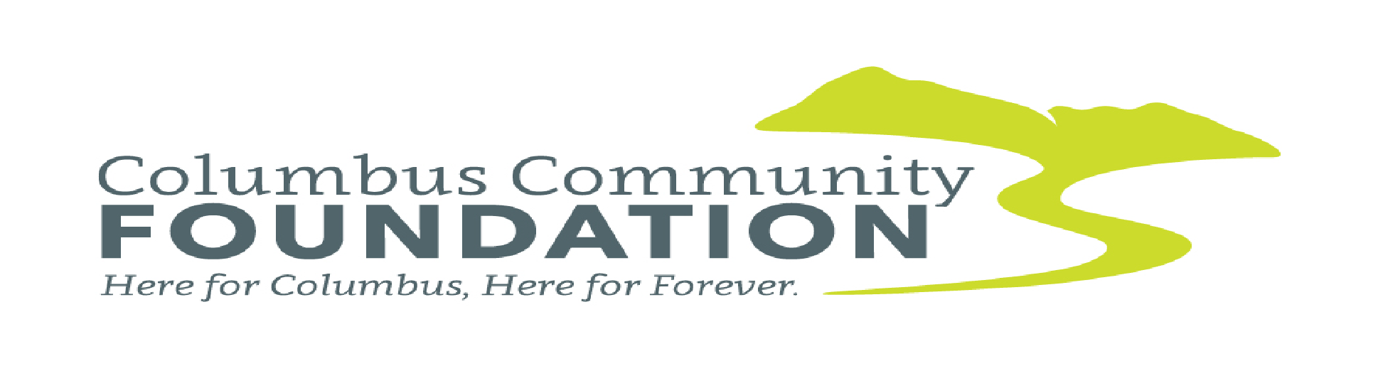
2026 Grant Application Cover Sheet

Name of Organization: _____________________________________________
Address: ________________________________________________________
Contact Person: __________________________________________________
Title: ___________________________________________________________
Phone: _________________________________________________________
Email: _________________________________________________________

Descriptive Title of Your Project: _________________________________________________________

Brief Description of Your Project and what will be done with the funds: (250 words max)
_____________________________________________________________________________________
_____________________________________________________________________________________
_____________________________________________________________________________________
_____________________________________________________________________________________
_____________________________________________________________________________________

Grant Amount Requested: $_____________________________________________________________

Check one or more: AREAS OF INTEREST
____Arts and Culture ____Basic Human Needs ____Economic and/or Community Development
____Education ____Natural Resources and Conservation

Signature: ____________________________________________________________________________
Title: ___________________________________________ Date: ________________________________

2026 Columbus Community Foundation Grant Information

Application Deadline: Sunday, November 1, 2026
To submit the application by mail: Columbus Community Foundation, PO Box 462, Columbus, MT 59019
To submit via email, send to: columbusmtcommunityfoundation@gmail.com. (Preferred method)
For questions, please email us at columbusmtcommunityfoundation@gmail.com. If you would like to discuss your project idea and/or application with a representative of the Foundation, please feel free to email us to setup a time.

Eligibility: All projects must be sponsored by an organization with 501(c)3 status or a tax exempt
governmental unit serving the Columbus Community. Grants cannot be awarded to religious
organizations for the sole purpose of their members. All projects must be designed to be completed
within one year and may not include salary requests or administrative fees. Any items or work included
in the proposal cannot be started prior to award. If your proposal has multiple phases, please detail
what our grant funds will be used for. Nonprofits are eligible for funding 3 consecutive years. An
incomplete application may be rejected at the discretion of the Columbus Community Foundation
Board of Directors. An organization may not submit more than one grant application in a year. Each
application must be limited to one project.

Areas of Interest: The CCF Supports Grants that address one or more of the following areas
(Check all that apply):
- Arts and Culture
- Basic Human Needs
- Economic and/or Community Development
- Education
- Natural Resources and Conservation
Application Package must include all the items listed:

• Grant Application Cover sheet (use cover sheet provided)
• Proposal Narrative: Include the following (7) items in your narrative.
(Maximum 3 pages for narrative, numbers 1-7) (70 percent of total proposal)
1. Organizational Background: What are the primary goals of your organization? How long has your organization been in existence? Who does it serve? How are you funded? What are your annual activities?

2. Describe your Proposed Project.

3. How does the proposed project address your organization’s primary goals?

4. How does the proposed project enhance the Community of Columbus?

5. How many people will benefit from the proposed project?

6. Collaboration – what current community support does your organization have for the proposed project? If your organization is part of a larger organization (i.e., department of a government agency) please provide in writing evidence the larger organization supports the proposed project.

7. Governing Board and Staff: Please provide a list of your Board of Directors (list their positions on the board and roles in the community (volunteer, staff, board, etc.) Is your board financially contributing to your organization? If so, what % of board members?

• Project Budget: BE SPECIFIC. You must use the Budget Form provided. (20 percent of total
proposal) Make sure to include all income and expenses related to the total project. Include
income (cash and in-kind) and expenses for all items related to the project, even if you are not
requesting funding for them. (For example: if you are requesting funding for only a printer, do
you have paper, cartridges, computer? Who is contributing the funding for these items or who
is contributing these items?) No salary or administrative requests are allowed.

• Project Schedule (10 percent of total proposal) including project start and completion dates.

• Overall Annual Operating Budget with Balance Sheet for your organization

• Copy of 501(c)3 designation letter

**Successful applicant organizations will be required to complete reporting forms within 6 months of
the grant award and must be willing to conduct a site visit regarding the proposed project with the
grant committee. **

What resources are required to complete your project?
Include a budget showing ALL expenses:

Item | Amount Requested from CCF | Amount from "other sources" | Total Cost of Item
PROJECT TOTAL

